Web Development Lesson Plan

|  |  |  |
| --- | --- | --- |
| Session: 1-2 weeks after open observation so it is not too fresh | Topic: Introduction to Python | Day: |

|  |
| --- |
| Lesson Objective:  This exercise will:   * Cover the basics of the Python programming language   The purpose of this lesson is also that   * Students can aquire basic Python skills |
| Materials Needed:   * Visual Studio Code * Internet Access * Web browser |
| Agenda:   1. Why Python (10 minutes) 2. Download Python (20 minutes) 3. Write a simple Python program (10 minutes) |
| Procedure:  Student can do this fully independently by reading the instructions, or someone can read the instructions to make sure the task is understood before doing the activity. The reflection part can be done with guided instructions, or in pairs with other students if available to compare notes. |
| Assessment/Check for learning:   * Students can identify concrete things that they missed in their observation (note that this is not a bad thing, the purpose of this lesson is to realize that intentionally looking for information comes with the ‘penalty’ of reduced attention to other things. |

What if:

* Student has already shown proficiency in that skill?
  + Pick a movie or episode in which a lot of things are happening, so that there are more things for the student to keep track of.
* Student is having a hard day and needs special accommodations?
  + Pick a movie or episode in which only a few things are happening, so that there are less things for the student to keep track of.
  + Instead of writing, the student can also take spoken notes with an audio recorder. This will be a bit trickier in the second part but audio in the movie can be supported with subtitles.

NOTES:

* Duration is approximately 50 minutes; can be adjusted by shortening the duration of the film clip. Less than 10 minutes is not recommended unless really necessary.

**Instructions**

**Why Python (10 minutes)**

Step 1:

As we covered previously, python is a robust programming language that is easy to learn. It is used in various applications such as data analysis, artificial intelligence, web apps, and automation. Python is easier to learn compared to traditional languages. We will use Python in course because the Django framework is built in Python. You do not need to be an expert in Python to start building web apps, this course will walk you through all you need to know in regard to Python.

Step 2:

Skim this article to learn why Python is preferred by developers:

<https://steelkiwi.com/blog/why-python-django-are-your-top-choice-for-web-development/>

**Download Python (20 minutes)**

Step 1:

If you do not already have Python installed on your computer, follow the instructions in the video below:

[Python Tutorial for Beginners 1: Install and Setup for Mac and Windows](https://www.youtube.com/watch?v=YYXdXT2l-Gg)

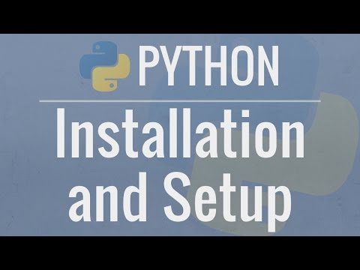

**Write a simple Python program (10 minutes)**

Step 1:

Open Visual Studio Code.

Step 2:

Open a new terminal.

Step 3:

Create a folder called “Lesson6” using the **mkdir** command.

Step 4:

In Visual Studio Code, on the left side bar click on the Explorer button (Icon with two files):

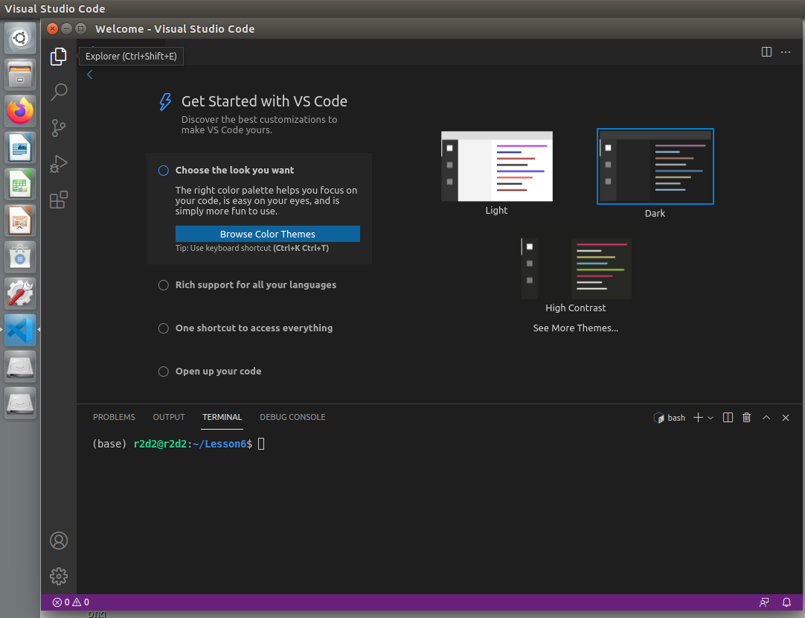

Step 5:

This will open the Explorer sidebar shown below.

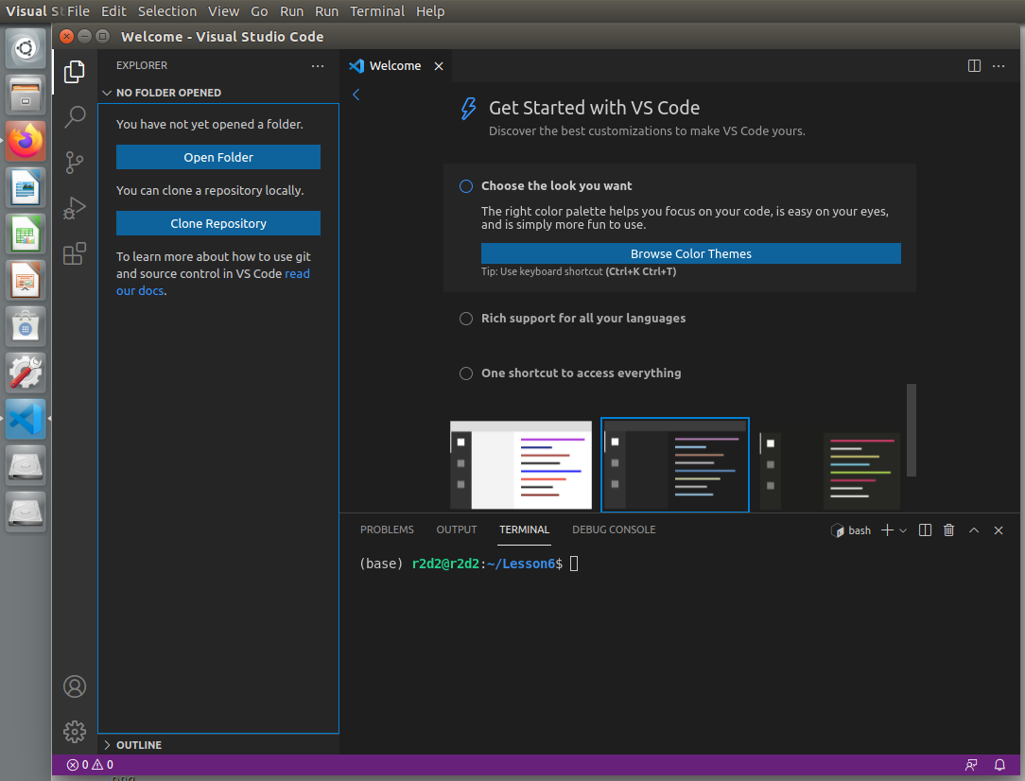

Step 6:

Click **Open Folder** and then open the Lesson6 folder. Your Visual Studio Code will refresh and you will need to open a terminal window again. Do this by going to **Terminal > New Terminal.**

Step 7:

Now you should see any empty side bar titled Lesson6. Right click inside the empty space and select **New File**

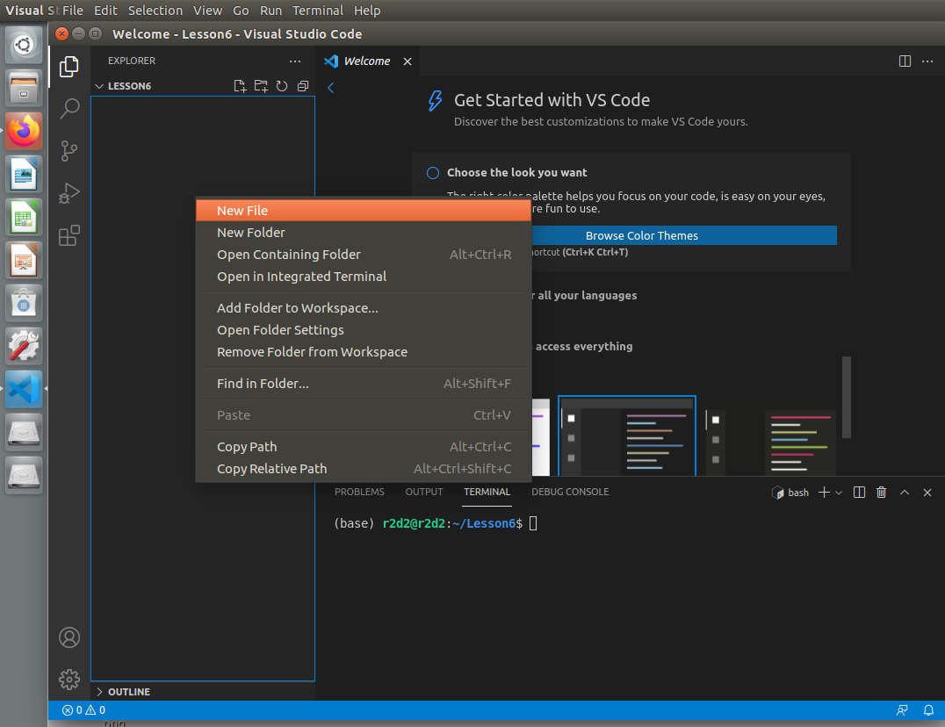

Step 8:

An empty rectangle will appear, simply type “lesson6.py” and press enter. You should now see the file in the file explorer and a new empty document in the center of Visual Studio Code.

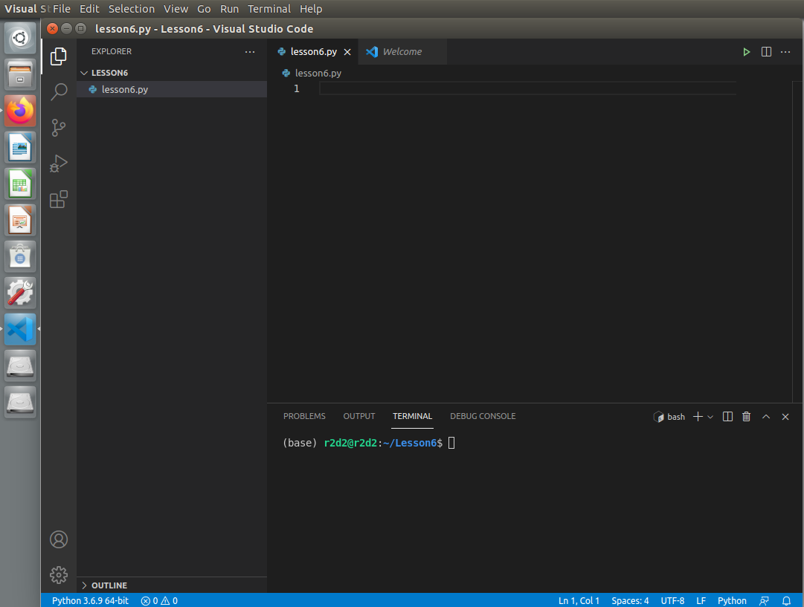

Step 9:

In the code editor type the following lines of code:

x = ‘Hello world’  
print(x)

Save the file after you have entered the code.

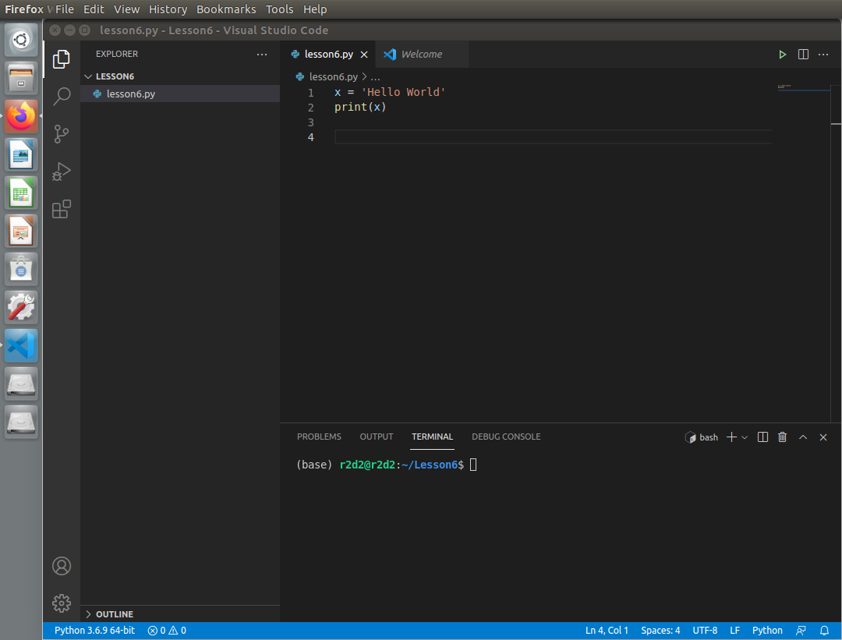

Step 10:

Next run the program. To do this type **python lesson6.py** into the terminal. Press enter to run. You should see your hello world message in the terminal.

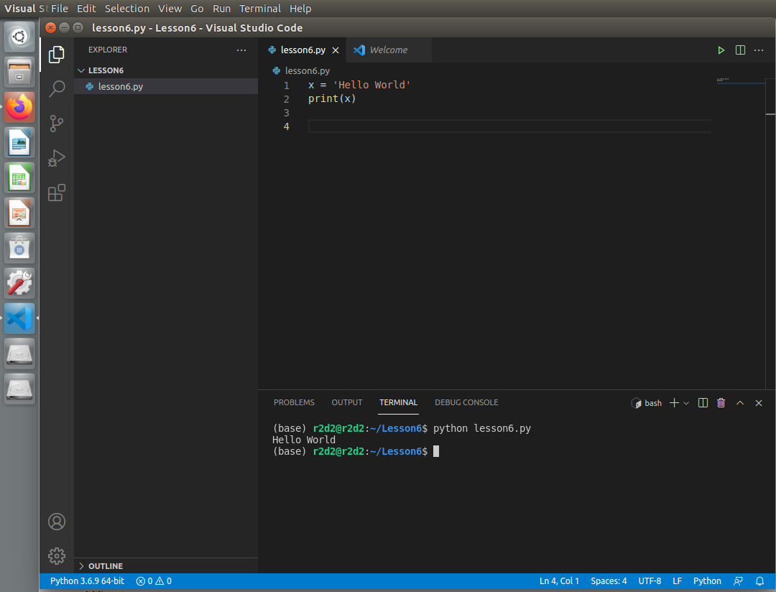

Congratulations, you have written your first Python program and successfully ran using the integrated terminal.

In the next lesson you will learn about Python virtual environments.